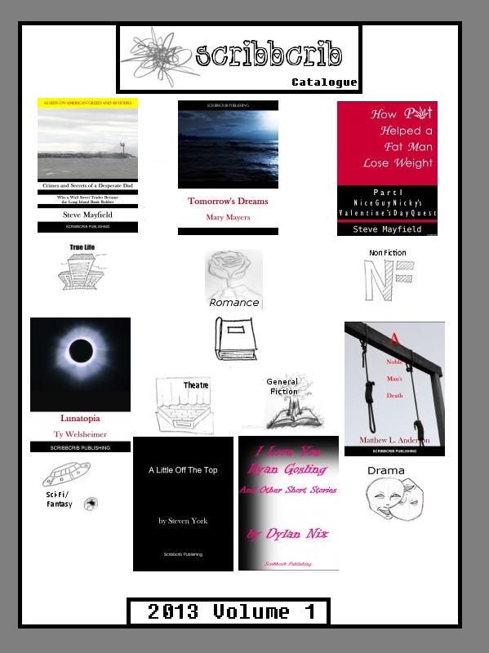

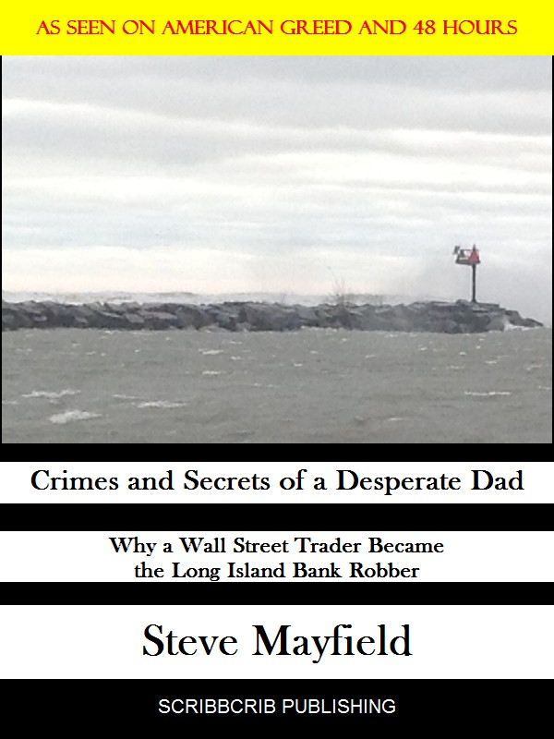

Title: Crimes and Secrets of a Desperate Dad

Author: Steve Mayfield

Date Published: 2-25-13

Word Count: 31,000

Genre: True Crime

A man who seemingly had everything…A Wall Street Commodities and Oil Trader living the good life. But the pressures of it all caught up to him and pushed him over the cliff. He became a bank robber, hitting 10 banks over the period of 4 months in 2004. ‘Crimes and Secrets of a Desperate Dad’ gives a message of pain, sorrow, and a chance at redemption all told through the words of Stephen Trantel, the Long Island Bank Robber.

_______________________________________________________________________________ 

Title: My Name is Bill

Author: William Alton

Date Published: 3-3-13

Word Count: 34,000

Genre: True-Life

The world is kind to many as they grow up. They become successful, law-abiding citizens out to live the American dream. Then, there’s Bill. Having dealt with a troubled child hood, including police officers, troubled parents, and death, Bill grows up in a different world from the rest of society. Bill explains his life in this memoir of nature versus nurture.

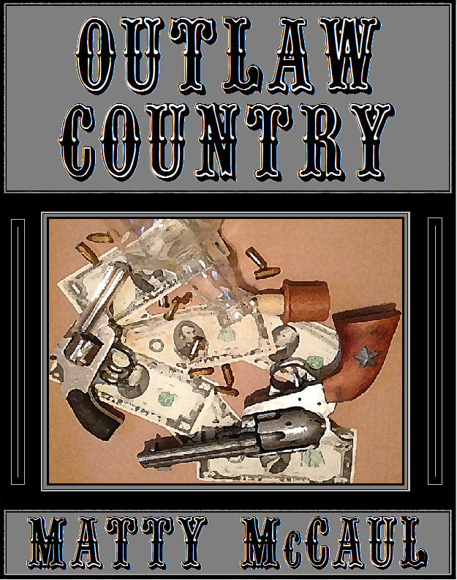

Title: Outlaw Country

Author: MattyMcCaul

Date Published: 5-26-13

Genre: Crime

Word Count: 137,000

Six very different people are about to cross roads, brought together due to a common denominator. They live different lifestyles; come from different towns and different times, but hold one similarity they can't deny... they are all wanted outlaws. Reputations and egos are put to the test, trust is questioned, a romance endures, and blood is spilt, all in the name of the score. The edge of your seat heist drama that is Outlaw Country,  a fictional retelling of the lives of some of America’s most notorious criminals, will keep you guessing in a uniquely written way that you've never seen before. MattyMcCaul takes us on a heart pounding journey from action to heart break, that is all too real to believe that it could be fiction

Title: What I Learned In God's Waiting Room

Author: Peter Fick

Date Published: 4-21-13

Word Count: 130,000

Genre: True Life

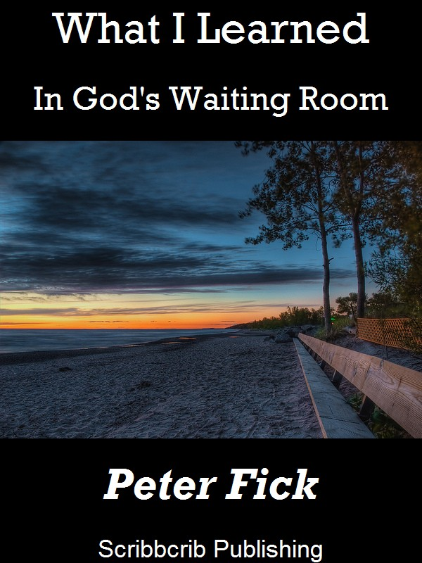

Quirky, is the best way to describe “What I Learned In God’s Waiting Room.” Peter Allen Fick packed up his family and moved to Boca Raton, FL to follow his wife’s passion for the state ala Jimmy Buffett dreams. What he found, instead, was his personal hell. But coming out of it with life lessons, and ingenious sensibility that all wish for. At the very least, you can learn about how to save money on insurance and how not to be a “sheep.”

__________________________________________________________

Title: The Peace

Author: Bill Norton

Date Published: 2-25-13

Word Count: 30,000

Genre: Sci-Fi



Three centuries of war have come to an end. Colonel James Abbott begins his journey back home to “normalcy,” as best he can with a family he barely knows. But whatever sense of peace that may be there is a lie. Someone or something from his past begins targeting his family. The war never really ended. Not for James.

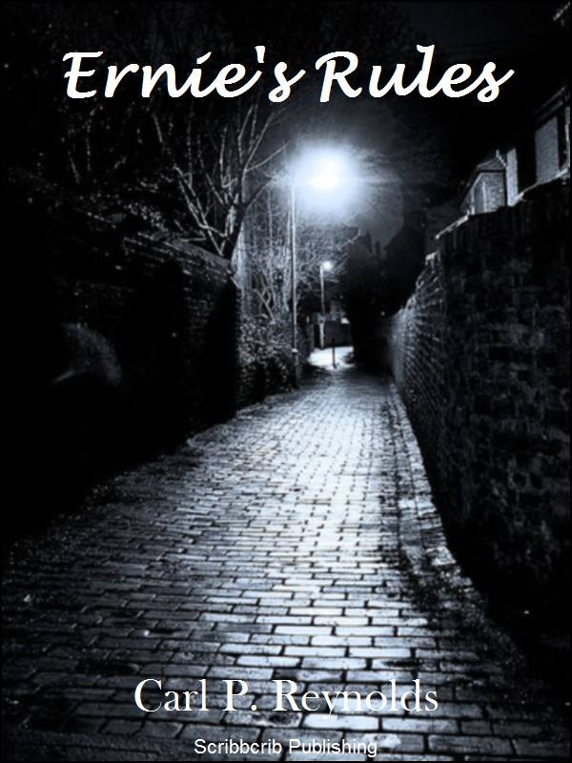

Title: Ernie's Rules

Author: Carl P. Reynolds

Date Published: 3-5-13

Word Count: 12,000

Genre: Crime

A man only needs a few things to get by. His health, his mind, and his rules. This short story follows the death of a man named Ernie, his rules, and how they intertwine with the lives of those around him. No one is immune from the rules, and everyone should follow them.

**__________________________________________________________**

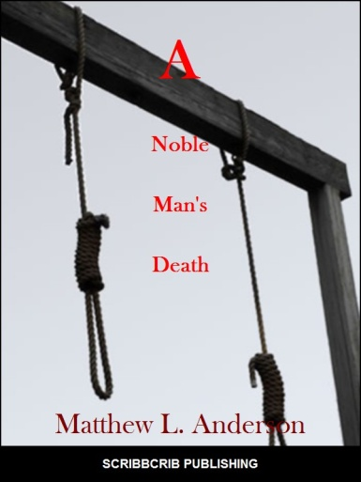

Christopher waits in his jail cell as his day in the gallows approaches. With visits from his son, Edward, and other important people in his life, he reconciles the crimes he committed, his reasons for killing the prince and facing the end of his days.

Title: A Noble Man's Death

Author: Matthew L. Anderson

Date Published: 2-25-13

Word Count: 8500

Genre: Drama

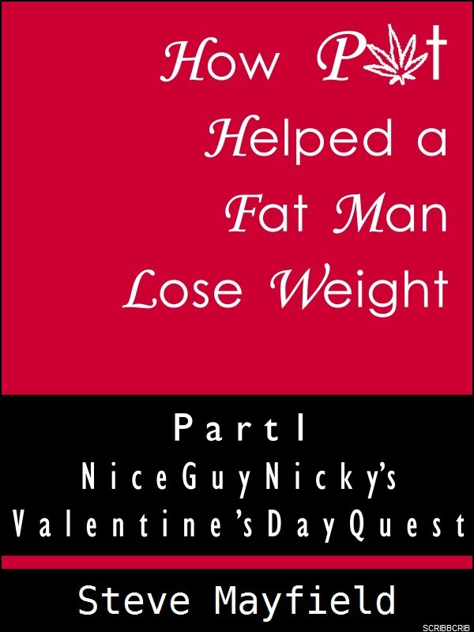

Title: How Pot Helped a Fat Man Lose Weight Part 1: Nice Guy Nicky's Valentine's Day Quest

Author: Steve Mayfield

Date Published: 5-28-13

Word Count: 18,000

Genre: Self Help

Ever struggled with the stress of weight loss? Have you been unable to get the desired results while putting forth the most effort possible? Are you tired of looking at the scale, stressed out after seeing minimal, if any results? "How Pot Helped a Fat Man Lose Weight Part 1" details the diet the narrator, Nicky, follows to shed over thirty pounds while smoking marijuana. One of the first books of its kind, "How Pot Helped a Fat Man Lose Weight Part 1" will surely help guide you to your ultimate destination.



Title: The Delaware River Author: John Bernardo

Date: 3-29-13 Word Count: 18,000

Genre: Non-Fiction, Educational

General George Washington and his troops crossed this river in New Jersey back on December 25, 1776 to win an infamous battle against the British in the Revolutionary War. The Delaware River has become an icon, captured in awe by Emanuel Gottlieb Leutze. But there is more to the river’s story. John Bernardo takes us on a journey through the river’s livelihood and its importance to the ecosystem, economy, and infrastructure of today.

Title: Down on Jack Author: Thomas Lee Howell

Date: 4-4-13 Word Count: 63,000

Genre: Drama

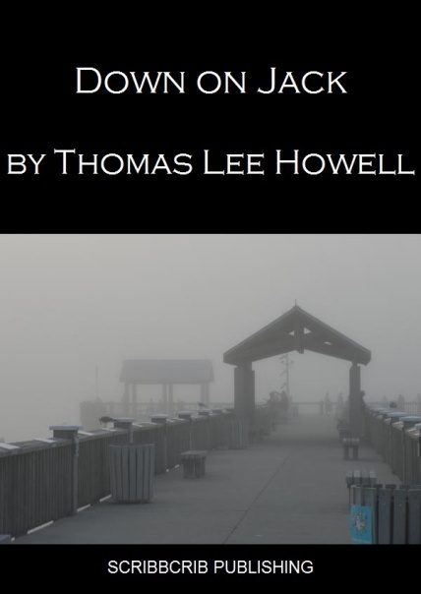

Jack wasn’t much of a religious man. He hadn’t been inside a church since his third and last wedding. Look how well that turned out. His wife had breathed a long, measured sigh of relief as she descended the courthouse steps. Their divorce was final. ‘Irreconcilable differences’ was the official cause listed on legal documents. Did she really know the man she married? Who was Jack Prime? Was he capable of murder?



“That’s what Chris has.” His mother heard the symptoms and she knew. Tourette Syndrome is a disorder that is very easily confused. A number of young men have it and never know. Chris Mason shares his story in an amusing and sorrowful tale that sheds light onto the truth of Tourette’s

Title: What Makes Me Tic Author: Chris Mason

Date: 4-12-13 Word Count: 105,000

Genre: True Life

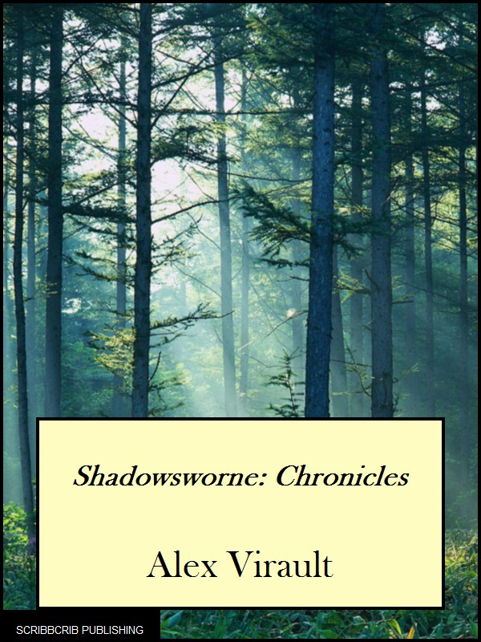 

Title: Shadowsworne: Chronicles

Author: Alex Virault

Date Published: 3-13-13

Word Count: 105,000

Genre: Fantasy

Title: You Can See If You Close Your Eyes

Author: Grayson Nyx

Date Published: 3-15-13

Word Count: 78,000

Genre: Drama

“Life is not the sport for spectators. Even they are afflicted. I just want to see where people run to when rules and religion will no longer harbor them.” ‘You Can See’ is one of those books that is hauntingly beautiful, with gorgeously described details and an evolving plot that you can’t tear your eyes away.

A story within a story, Chronicles begins the tale of several villagers, setting out accidentally into a world far more complex than their own, exploring cities and towns they never knew existed, all with a lingering question in their mind: Who really started the fire?



Title: Chronicles of a Lesbian Bartender

Author: Kim Hancock

Date Published: 2-25-13

Word Count: 64,000

Genre: True-Life

The author of this adult novella couldn’t have said it better. “A love story with a few twists, some major dysfunction, and a little spiritual growth for good measure.” Chronicles takes a look at relationships and kicks it into a new direction. “50 Shades of Grey”, beware. We are very excited to be bringing you this piece!

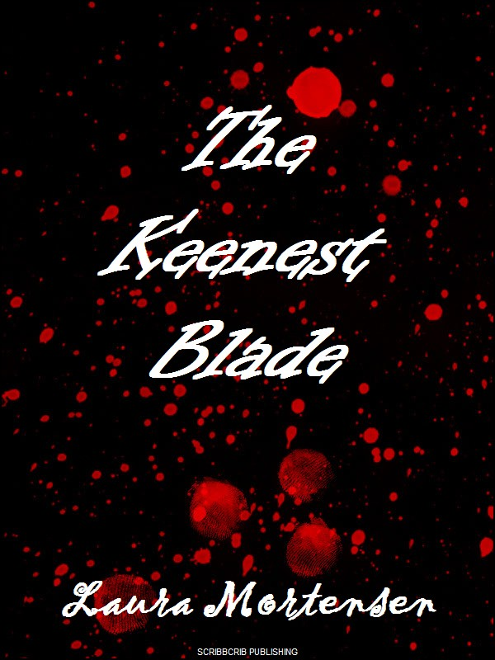

Title: The Keenest Blade

Author: Laura Mortensen

Date Published: 4-21-13

Word Count: 3,200

Genre: Fantasy

A knife she sold became the weapon. They were all weapons. Each one sent back with a permanent bloodstain. Genevieve Adair’s life became flipped from the moment the FBI knocked on her door. She was involved, but didn’t know how. Her insight as a necromancer became the key to solving the murders, but at what cost to her own safety? This short story grips you from the beginning and doesn’t let go; it is everything you would never expect with this twisted crime drama.

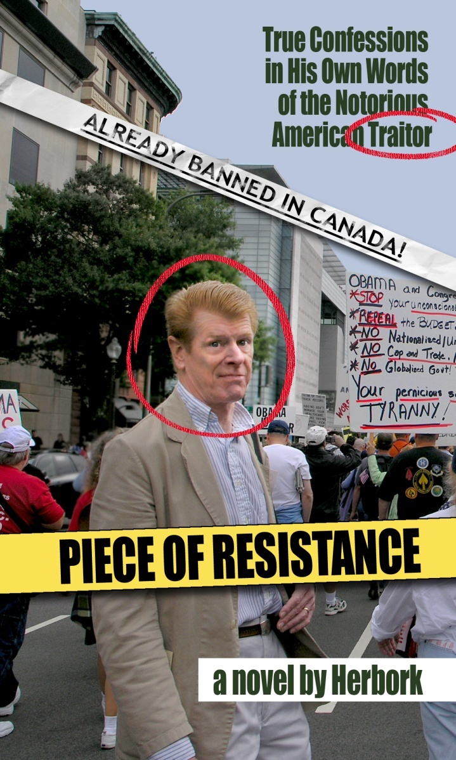

Tired of the government’s lack of action, four men make a resolve to stop a threat greater than themselves: terrorism. This story takes the reader on an unprecedented, and exciting ride. Danger at every corner. Fear at every second. All in the name of justice.

Title: Piece of Resistance

Author: Herbort "Herbork" Borkland

Date Published: 4-28-13

Word Count: 58,000

Genre: Drama

__________________________________________________________

Title: A Little Off The Top

Author: Steven York

Date Published: 2-24-13

Word Count: 6,200

Genre: Theatre

Clyde, a down on his luck barber lives in a world where most people work and are productive members of society, while others choose to drink, smoke, and do drugs while contributing nothing. A barber by trade, and a productive member of society, Clyde’s hobbies inter-mesh with the dregs of the world and crosses into a dark path.

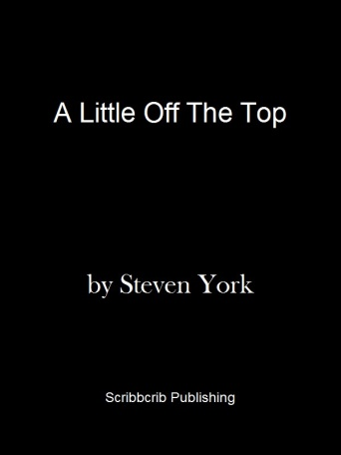



Title: Honeysuckle Bend Author: Cyrus Gaites

Date Published: 2-22-13 Word Count: 85,000

Genre: Drama

Stuck in prison, counting down the days until parole, trying to make it through the course; he found a new sense of life, friendship, and happiness behind The Walls. And maybe a little bit of magic. A twist on the typical prison story, “Honeysuckle Bend” will pull at your heart-strings. Taking place deep in the heart of Texas, you’ll find yourself entranced by the wonder of Cyrus Gaites’ story.



Title: Blood and the Dance Author: David R. Waters

Date Published: 4-21-13 Word Count: 71,000

Genre: Drama

Have you ever heard of those spirit quest, a journey that a man must take in order to reach adulthood in accordance with tradition to some native American tribes? Blood and Dance explores this with a unique duality and modernism that hasn’t been seen. Two men experience this journey in a subtle ways the reader would never imagine.

Title: Lunatopia Author: Ty Welsheimer

Date Published: 2-22-13 Word Count: 51,000

Genre: Fantasy



Hank woke up at his friend’s home, dazed and only slightly confused from a night out celebrating the first day of summer. But the innocence of childhood is lost when he returns home. The television is on. A clock counting down with 50 minutes left. No one knows what it means.

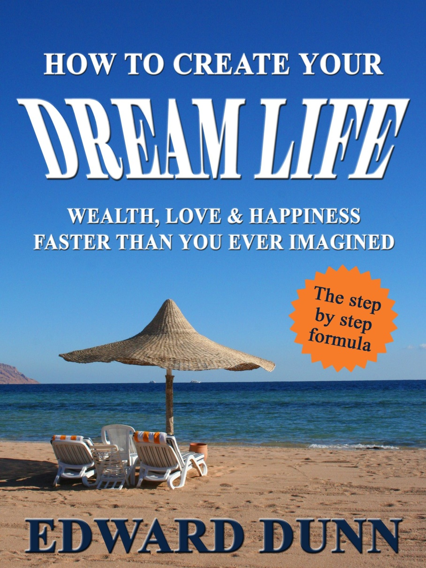

Books like The Secret and Think and Grow Rich explored a concept known as the law of attraction. Millions read those books, applied what they taught only to find themselves wondering why it wasn’t working. The answer is simple – their beliefs were in the way. The law of attraction is simply the way the universe works however, belief is a crucial component. Most of us harbor unconscious beliefs like, “Life is hard, making money is difficult, I can’t control my health, I can’t find love or I don’t deserve these things.” Those beliefs will stand in opposition to the law of attraction and prevent the things you desire from showing up in your physical reality. In his new book Edward Dunn has created a formula built on the power of NLP (Neuro-Linguistic Programming) quantum physics, psychology and ancient spirituality that will erase the limiting beliefs and make the law of attraction fool-proof. It is easy to learn and even simpler to use – and it works for anyone regardless of education level or present circumstance. This is the book that will finally hand you the power to create your dream life. Wealth, love, happiness – whatever you dream of, the formula can deliver.

Title: How to Create Your Dream Life

Author: Edward Dunn

Date Published: 3-14-13

Word Count: 22,000

Genre: Self Help

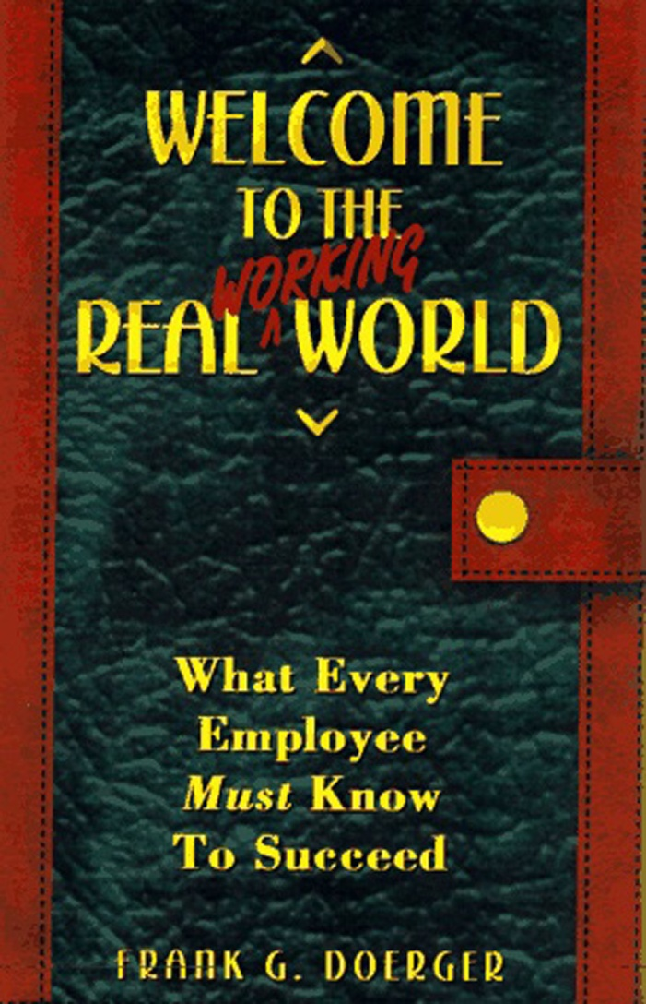

Title: Welcome To The Real Working World

Author: Frank Doerger

Date Published: 5-12-13

Word Count: 30,000

Genre: Self Help, Educational

Hunting for a job, searching hundreds of internet postings daily, finding and settling into a career, staying on top of your work game: these are becoming incredibly common-place in our ever-changing economy. Welcome to the Real World is a guide-book for those starting out in the life or work or are long-time veterans. It provides tips, advice, and thoughtful insight into what goes on in the corporate world, and how to navigate it to achieve your goals.



"You've got to stop killing people."

A tracker is given a task: bring back the daughter of a vampire traveling with a group of musicians before the solstice. A task so simple leads him to an unbelievable journey. You won’t find anything sparkling here. This is a gritty vampire tale told through the playful mind of Funi Daniels.

Title: The Hurdy Gurdy Troubadours

Author: Funi Daniels

Date Published: 3-15-13

Word Count: 95,000

Genre: Drama



Title: Angus Finn and the Celtic Cross

Author: Anna M. Kelly

Date Published: 3-4-13

Word Count: 15,000

Genre: Fantasy

Angus Finn is not your typical protagonist. Overweight. Clumsy. A little shy at times. But from his simple nature comes the heart no man, or Leprechaun could ever match. When his village and people are threatened he turns into the hero we all long to be. This fantasy tale is delightfully written by Anna M. Kelly will be a breath of fresh air for fiction readers.

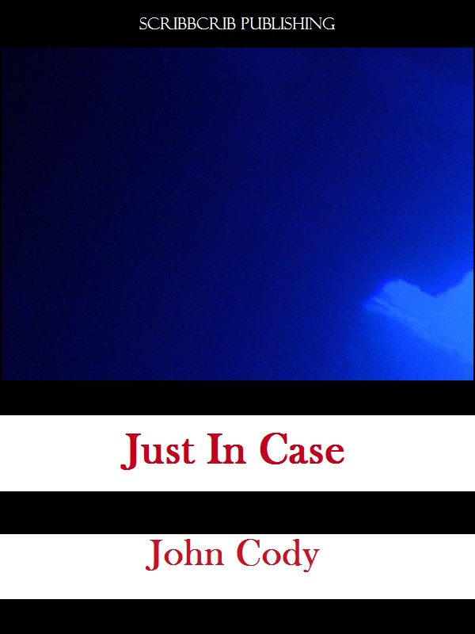

Steve Wright, an accomplished author and journalist, tells the tale of a deep-sea recovery mission gone wrong. At the site of recovery mission of an unnamed object, several countries, all rivaling to acquire the technology, stand over the site and battle with each other over it. Is the foreign technology worth going to war over?

Title: Just In Case

Author: John Cody

Date Published: 3-10-13

Word Count: 9400

Genre: Fantasy

 

Title: Tomorrow's Dreams

Author: Mary Mayers

Date Published: 5-15-13

Word Count: 70,000

Genre: Romance

Title: So You Wanna Date An Activist?

Author: Barb Payne

Date Published: 5-1-13

Word Count:

Genre: True Life

Dating an activist sounds like a noble choice. They’re spirited, determined, and willing to fight for the little people against the evil corporations. Or so we think. Barb Payne walks us through how to date one and what goes on in the activist community, with insight and humor that make this book well worth the read.

Mariot has lived a life most of us fear. Until her mother’s death, she was a child living with abuse and pain. She took a chance to run away from it all. Grabbing her newborn sister, she fought to hide from her family and live again. Tomorrow’s Dreams is a wonderfully crafted tale that gives us hope even during the darkest of hours.

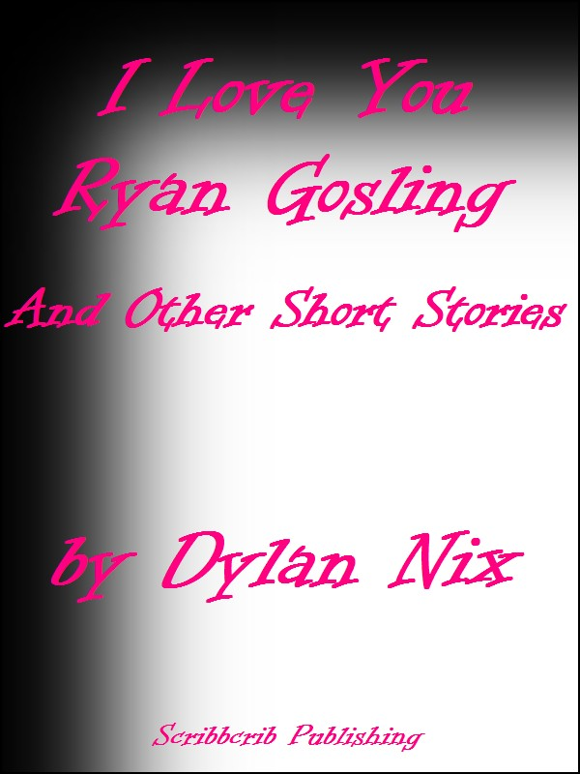

Title: I Love You Ryan Gosling And Other Short Stories

Author: Dylan Nix

Date Published: 5-21-13

Word Count: 25,000

Genre: General Fiction

Dylan has just graduated high school. No sights set on the future. No plans for moving forward. His only concern was Ryan Gosling. The man. The actor. The myth. He had to meet him. “I Love You Ryan Gosling” is an unexpected and delightful novella about a young man’s journey to meet his idol.

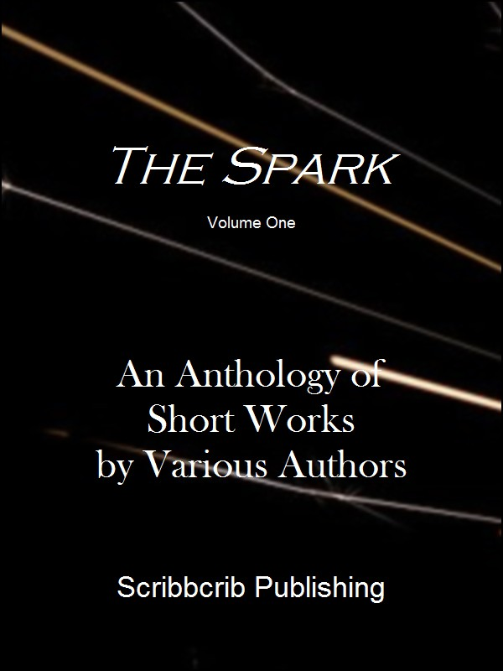

Title: The Spark, An Anthology of Short Works

Artist: Various

Date Published: 3-12-13

Word Count: 21,000

Genre: Anthology

We here at ScribbCrib Publishing are proud to present our first edition of The Spark. In this edition we bring you a collection of the twelve following short stories from first time authors.

* **The Titanic Stopped at Raven’s Talon** by Greg Przywara
* **Distorted** by Stacy Scales
* **Beckon** by Asya D. Ring
* **Broken** by Lesley Alexander
* **Life With Blake** by Lisa Marie Lopez
* **Runny Skin** by Suzanne Scacca
* **While the Sun** **Was Out** by Scott Cooper
* **The Call** by Edmund Attansio
* **Clear, New Year** by Rosemarie Mattke
* **Broken** by Christopher Ross
* **Forced Fear** by Dustin Davila
* **Kayla’s Smile** by Cassandra Nordeng